**Project 3 - texture**

Screenshot:

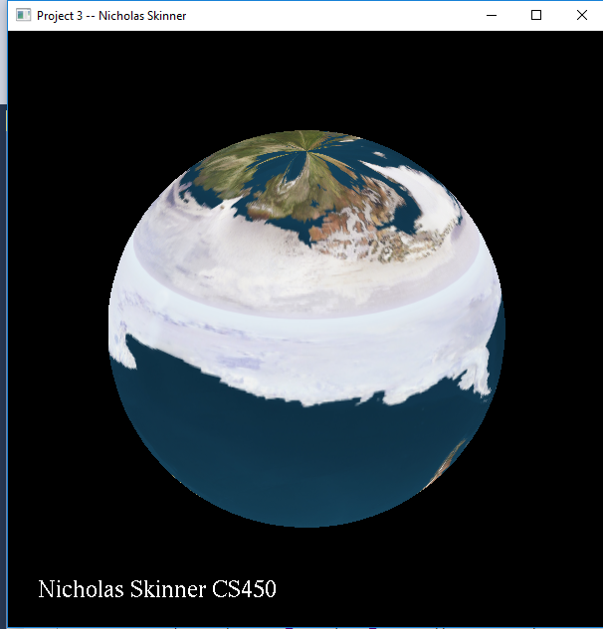

Video Link: <https://media.oregonstate.edu/media/t/0_blt43djq>

I’m uncertain if my transformation is non-trivial or not, it consists of transforming the s and t values, as well as drawing the image upside down and rightside up over and over.

Thanks, and have a great day!